**Newsletter #12September2018**

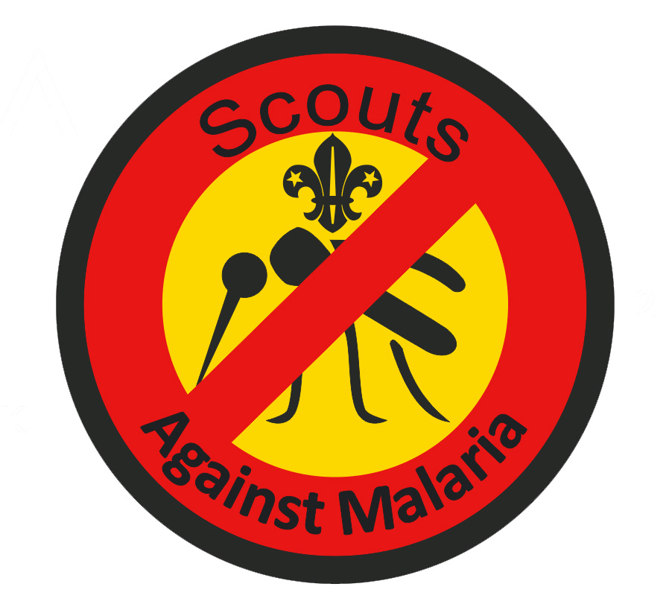

**Combating malaria in the African Scout Region**

**Sustainable development goals**

Following the success of the Millenium Development Goals (2000-2015),the United Nations collectively agreed a new set of Sustainable Development Goals for the period 2016-2030 with the aim of ‘*leaving no one behind*’.

Combating malaria forms part of the *healthy living goal* and in this issue we discuss not only the educational and fund raising activities in the UK, but also the outcomes of 15 campaigns by Scouts in 4 African countries.

Unlike infectious diseases which are encountered in temperate climates and for which vaccines are available, *no vaccine is currently available* to protect against the introduction of the malaria parasite into the blood stream .As symptoms of malaria include very high temperature, vomiting and diahorrea, young people under age of 5 are particularly vulnerable and can die as a result of contracting this disease unless treatment can be initiated within 12 hours. As the *anopheles* mosquitos are active at night, the simplest and most effective long term solution is to sleep under a *bed net* which is impregnated with an insecticide which can kill the mosquito.

**Africa’s burden**

Over *half the population at greatest risk* from malaria in Africa still sleep unprotected by mosquito nets which cost about £2 - 3 each. However such nets must be correctly used and cared for. The African Region continues to bear an estimated 90% of all malaria cases and deaths worldwide. Fifteen countries – all but one in sub-Saharan Africa – carry 80% of the global malaria burden.Clearly, if we are to get the global malaria response back on track, supporting the most heavily affected countries in the *African Region must be the primary focus* [WHO World Malaria Report]

**SAM initiative** forms part of Scouting’s *global programme zone* in which Scouts learn about the disease and how they can help to alleviate suffering and save lives.

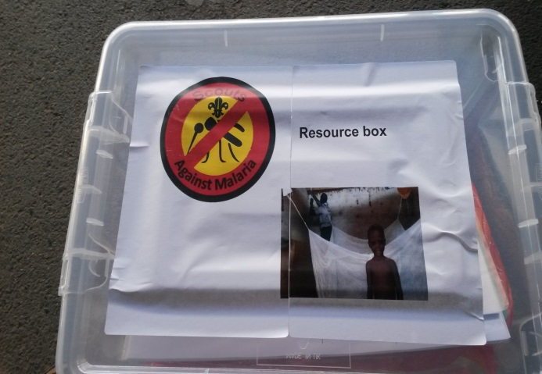We have developed a set of activities which can form the basis of one (or more) meetings of Scouts of any age range from Beavers through to Explorers and Network. These activities can be down loadedfrom our SAM website where it is also possible to order a resource box containing almost all resources needed to organise such activities.

The resource box was for example used to organise activity evenings for each of the 1st Winchester Cub Packs. Not only did the Cub Scouts learn something more about the disease and how it could be fought, but then they went on to raise in excess of £1000.

These funds have now been sent to the Malawian Scout Association to fund their 3rd campaign to distribute long life impregnated bed nets.

**Gambiaislikely to be the first sub-Saharan African country to eliminate malaria through a combination of large scale distribution of long life impregnated bed nets and residual indoor spraying.Distribution of long life bed nets by Scouts to vulnerable families in Soma and some of the outlying villages has contributed to this success.**

**Ghana The 4th campaign was undertaken early in August by the Ghanian Scouts in the Anlocommunity together with a group of Scouts from Kent led by Alan Noake who were spending 2 weeks in the Region helping to refurbish local schools. Some 200 bed nets were purchased and distributed with funds raised by UK Scouts and these were distributed to vulnerable families as well as helping erecting where necessary. But like all campaigns in all 4 African countries to date, they were only able to provide nets to *some of the many vulnerable families*.**

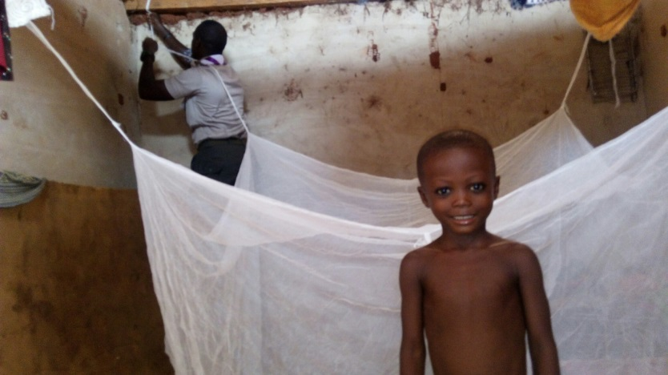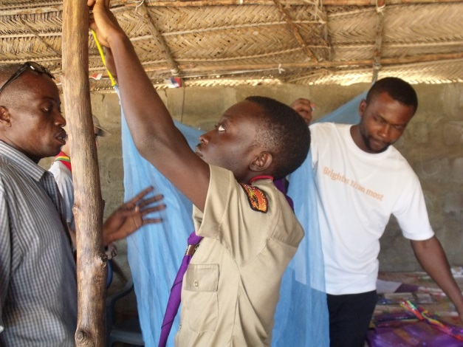

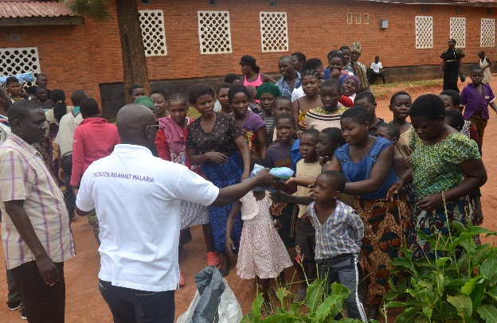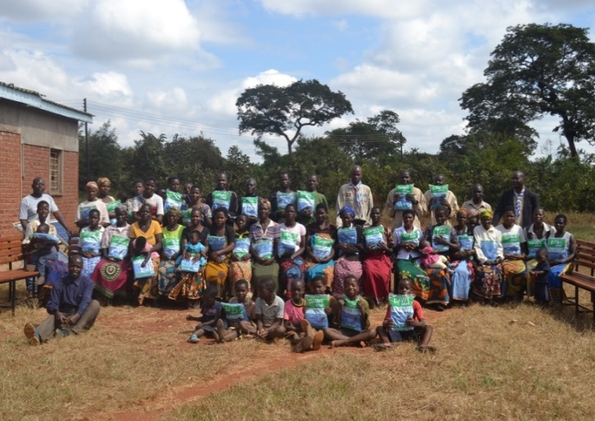**Uganda. 4 campaigns have been organised in different parts of the country and all have succeeded with the help of the local health officers to identify and provide nets to vulnerable families which are either those with children under the age of 5 or expectant mothers.**

**Malawi.** A second distribution campaign was heldin May in two districts.Lilongwe Rural and Mzuzu.Howie Maujo,their Executive Commissioner observed that ‘The SAM project keeps on generating demands on impregnated mosquito nets since government has not rolled out its distribution program. Only expectant women have the opportunity to receive one during antenatal service. Both District Health Officers have recommended extensive education campaigns and disinfection program in some areas deemed as essential’.

**Join the fight against malaria**

Beneficiaries at Galang’ombe Health Centre Lilongwe Rural, Malawi

Beneficiaries queuing up in Mzuzu to getthe insecticide treated bed nets

If your Section/Group is willing to join the global partnership to fight malaria, visit our website [www.scoutsagainstmalaria.org.uk](http://www.scoutsagainstmalaria.org.uk)or email us at [info@scoutsagainstmalaria.org.uk](mailto:info@scoutsagainstmalaria.org.uk).

|  |
| --- |
| Any Scout who learns about malaria and helps to limit its impact by raising funds, distributing nets or educating families about its symptoms and where help can be sought if bitten, is entitled to wear the SAM badge |

**.**