**Newsletter #13January 2019**

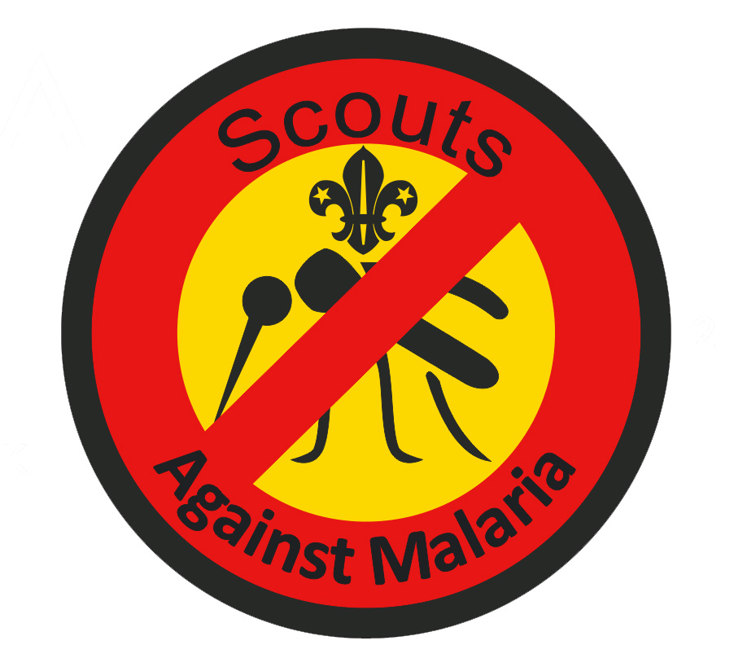

In this issue we discuss the principal findings of the 2018 World Malaria report, Scouting’s support for the UN’s Sustainable Development Goals, the most recent SAM campaign in Malawi and how Hertfordshire is planning to reduce the incidence of malaria in Burkina Faso.

|  |
| --- |
| *Our New Year wish is that Scouting can make a difference to reducing malaria deaths in Africa* |

**Sub Saharan Africa bears the burden**

The latest *World Malaria*report draws on data from 90 countries and areas with ongoing **malaria** transmission and was released on 19 November 2018. It tracks investments in malaria programmes and research as well as progress across all intervention areas: prevention, diagnosis, treatment and surveillance. It also includes dedicated chapters on malaria elimination and on key threats in the fight against malaria.

The World Health Organisation (WHO) observedthat NO significant progress was made in reducing global malaria cases between 2015 and 2017. There were an estimated 219 million cases and 435,000 related deaths in 2017.

90% of malaria cases and a similar proportion of the deaths occurred in the WHO African Region with 15 countries in sub-Saharan Africa and India carrying almost 80% of the global malaria burden. In addition the 10 highest burden countries in Africa reported *increases* in cases of malaria in 2017 compared with 2016. Children aged under 5 years remain the most vulnerable group affected by malariaaccounting for 60% of all malaria deaths worldwide.

**Insecticide- treated mosquito nets**

*Plasmodium falciparum* is the most prevalent malaria parasite in the WHO African Region, accounting for almost all malaria cases. This parasite is carried by the *anopheles* mosquito which is only active at night and so the most effective vector control is to sleep under an insecticide- treated mosquito net (ITN).

|  |
| --- |
| Bed net manufacturers reported that over the period 2015 to 2017, some 459 million bed nets were distributed in sub Saharan Africa and yet by the end of 2017, WHO estimated that **only 50%** of this Africa population (some 100 million people) were sleeping under these bed nets. WHO also estimates that coverage has only marginally increased since 2015.  Clearly the distribution process is *very inefficient* and the big question is whether the Scouts in these 15 African countries could make a difference by selective targeting of the most vulnerable families working in conjunction with the local health officers.  This could only happen if we could obtain these nets as free issue |

**WHO’s conclusions**

The challenges facing the global malaria response are many, and immediate barriers to achieving the fast-approaching milestones for 2020 and 2025 are malaria’s continued rise in countries with the highest burden of the disease and inadequate international and domestic funding. At the same time, the continued emergence of parasite resistance to antimalarial medicines and mosquito resistance to insecticides pose threats to progress.

**World Scout Movement takes up the challenge of Sustainable development goals(SDG)**

On November 29 the World Organisation of Scout Movementslaunched its new mobilisation campaign *Scouts for SDGs* at the UN Headquarters in New York. In launching this initiative, it noted that Scouting has made an extraordinary contribution over the years to improve the sustainability of our planet, promote peace, and tackle inequality. Earlier this year Scouts surpassed the milestone by giving more than one billion hours towards sustainable development through local projects under World Scouting’s programmes, including the flagship Messengers of Peace initiative.   
  
Now, as a global Movement, Scouting will take that commitment one step further with [Scouts for SDGs](https://scout.us10.list-manage.com/track/click?u=2036eac60a14e6549e2c8f745&id=d7c403c11e&e=79fe56f534). By 2030, this unprecedented activation aims to engage 50 million young people in a coordinated effort to deliver two million local projects and an additional three billion hours of service for the 17 SDGs of which combatting malaria forms part of the *healthy living goal*.

**3rd Campaign in Malawi**

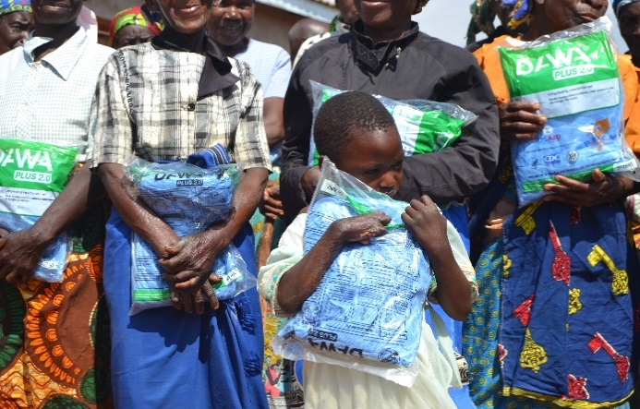The Malawi Scout Association undertook its 3rd campaign to reach out to vulnerable groups of people in the district of Mzuzu (Geisha) and Lilongwe (Khongoni) where people with physical challenges, orphans, widows and elderly were identified as beneficiaries of this distribution of impregnated mosquito nets.The exercise identified 200 beneficiaries, 150 for Mzuzu and 50 for Lilongwe. The project was implemented without difficulties, though demand looks to be increasing each time of distribution. These funds were raised by the two Cub Packs of 1st Winchester, Hampshire

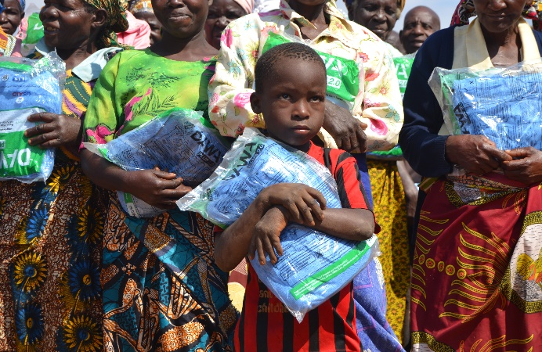

This identification exercise unveiled*another* vulnerable group of people living with HIV who expressed the desire for more mosquito nets to reach more people living with the virus since malaria poses as a great threat to their health and wellbeing.

**Burkina Faso**

Hertfordshire has raised considerable funds to support a SAM Project in a 5th African Country that is Burkina Faso (formerly Upper Volta).  Malaria remains a serious public health problem in this French-speaking country, despite the implementation of preventive and curative measures. It constitutes the first cause for consultation, hospitalization and death in their health facilities.

Statistics from the national health information system reveal that children are the most affected with 44% of the reasons for consultation; 53% of hospitalizations and 30% of deaths. In 2016 malaria affected about 9.8 million people, 4,000 deaths, including 3,000 among children under five**.**

**Join the fight against malaria**

If your Section/Group is willing to join the global partnership to fight malaria, visit our website [www.scoutsagainstmalaria.org.uk](http://www.scoutsagainstmalaria.org.uk)or email us at [info@scoutsagainstmalaria.org.uk](mailto:info@scoutsagainstmalaria.org.uk). Any Scout who learns about malaria and helps to limit its impact by raising funds, distributing nets or educating families about its symptoms and where help can be sought if bitten, is entitled to wear the SAM badge. Editor: Rayner Mayer